  





**Eco-Friendly Habit Tracker**



|  |  |
| --- | --- |
|  |  |
|  |  |
|  |  |
|  |  |

**Deliverable number:3**

**Date of submission: 04-05-2025**



**Eco-Friendly Habit Tracker**

**Introduction**

In **today's fast-paced world**, maintaining positive habits while balancing work, health, and personal growth can be challenging. The **Eco-Friendly Habit Tracker** is designed to help users effectively manage their daily routines by providing a structured and intuitive tracking system. To ensure smooth development and implementation, the project follows an organized **To-Do List**, where key tasks are systematically planned before execution. The initial phase of development focuses on essential features such as **user registration, login, habit creation, editing, deletion, and category assignment**. By addressing these fundamental tasks, the project establishes a strong foundation for a seamless and efficient habit-tracking experience, ultimately empowering users to stay consistent and motivated in their journey toward self-improvement.

**User Stories**

1. **User Sign-Up and Login** As a user, I want to sign up and log in so that my habit data is saved and synced across devices.
2. **Habit Management** As a user, I want to create, edit, and delete habits and assign them to predefined categories.
3. **Progress Tracking** As a user, I want to see visual charts and logs of my habit performance to track my improvements.
4. **Reminders & Notifications** As a user, I want timely reminders to complete my habits, so I never miss an important task
5. **Detailed Habit History**

As a user, I want to view a detailed history of my habits to analyze past performance

1. **Streaks and Goal Achievement System**

As a user, I want to earn streaks for maintaining consistent habits so that I feel motivated to keep progressing

1. **Customizable Dashboard**

As a user, I want to customize my dashboard to focus on the metrics that matter most to me, allowing for a more personalized experience

1. **Final Integration and Polishing**

As a user, I want the final product to be fully integrated and bug-free, ensuring a smooth and enjoyable user experience.

### User Stories and Specifications (Sprint 3)

1. **Streaks and Goal Achievement System**

**● User Story:** As a user, I want to earn streaks for maintaining consistent habits so that I feel motivated to keep progressing. **● Sub-User Stories:**○ As a user, I want to receive notifications when I hit a streak milestone.  
○ As a user, I want to see my current streak displayed prominently on my dashboard.  
○ As a user, I want to be rewarded with badges for achieving streaks.

**2.** **Customizable Dashboard**

**● User Story:** As a user, I want to customize my dashboard to focus on the metrics that matter most to me, allowing for a more personalized experience. **● Sub-User Stories:**○ As a user, I want to choose which metrics to display on my dashboard.  
○ As a user, I want to rearrange the layout of my dashboard components.  
○ As a user, I want to save my dashboard preferences for future sessions.

3.**Final Integration and Polishing**

**● User Story:** As a user, I want the final product to be fully integrated and bug-free, ensuring a smooth and enjoyable user experience.  
**● Sub-User Stories:**○ As a user, I want to report any bugs or issues easily within the app.  
○ As a user, I want to receive regular updates about bug fixes and new features.  
○ As a user, I want to experience seamless transitions between different sections of the app.

**Scrum Boards**

**Snapshot1**

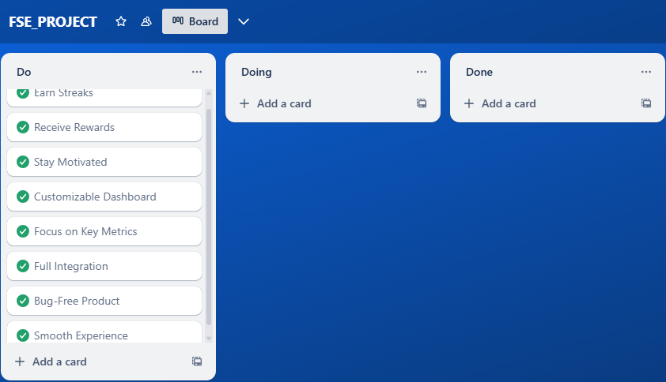

**Snapshot2**

**Snapshot3**

**Workload Division**

| Team directory | | |
| --- | --- | --- |
| **Team Member** | **Role** | **Responsibilities** |
| **Muhammad Daniyal Qureshi** | Lead & Backend Developer | Backend development, database integration, API implementation, and ensuring data security. |
| **Muhammad Ahmad** | Frontend Developer & Architect | UI development, integration of charts and reminders, frontend logic implementation, and interface responsiveness. |
| **Muhammad Sufyan** | Requirement Engineer & Tester | Requirement documentation, functional testing, validation of features, and bug reporting. |

**Full Implementation Screenshots**

**Signup:**

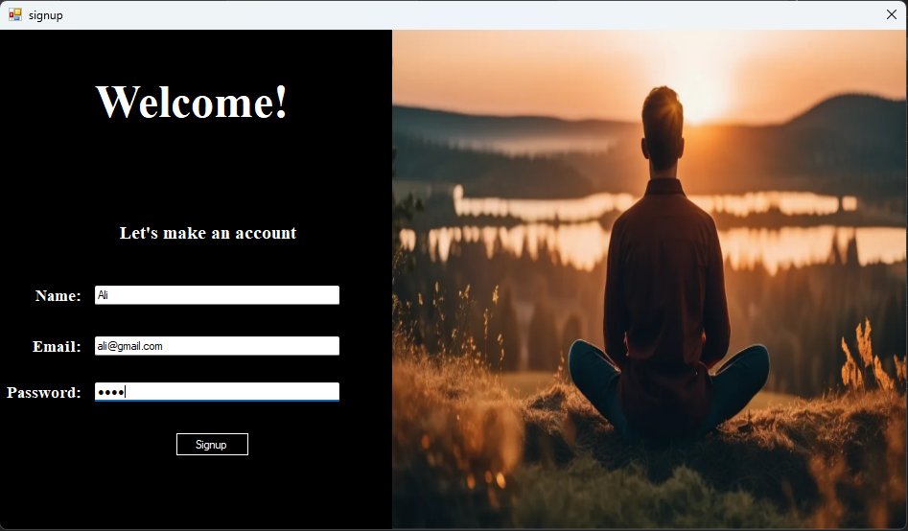

**Login:**

**Main Page:**

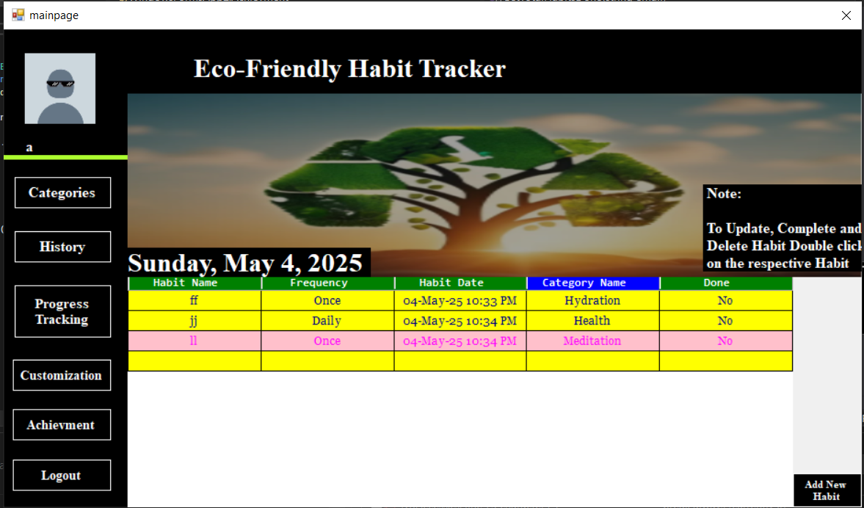

**Add Habit:**

**Upload Picture:**

**Update Habit:**

**Delete Habit:**

**Habit Categories:**

**Notifications and Reminders:**

**History:**

**Progress Tracking:**

**Customization of Dashboard:**

**Streaks and Goal Achievement:**

**Design**

1. **Activity Diagram**

**Page 1:**

**Page 2:**

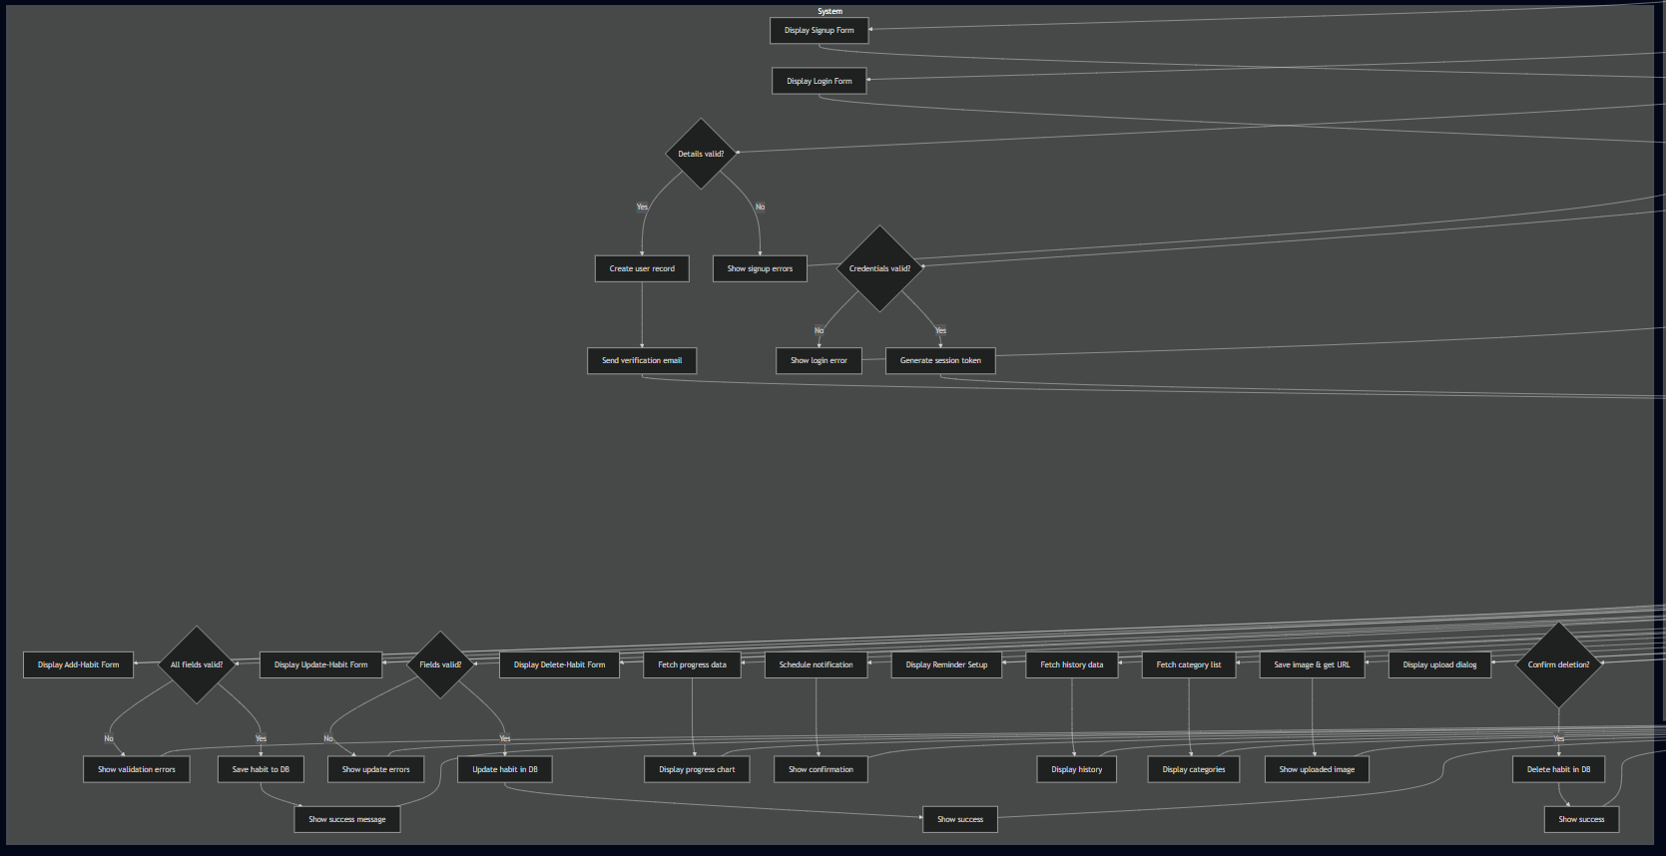

1. **Sequence diagram**

**Page 1:**

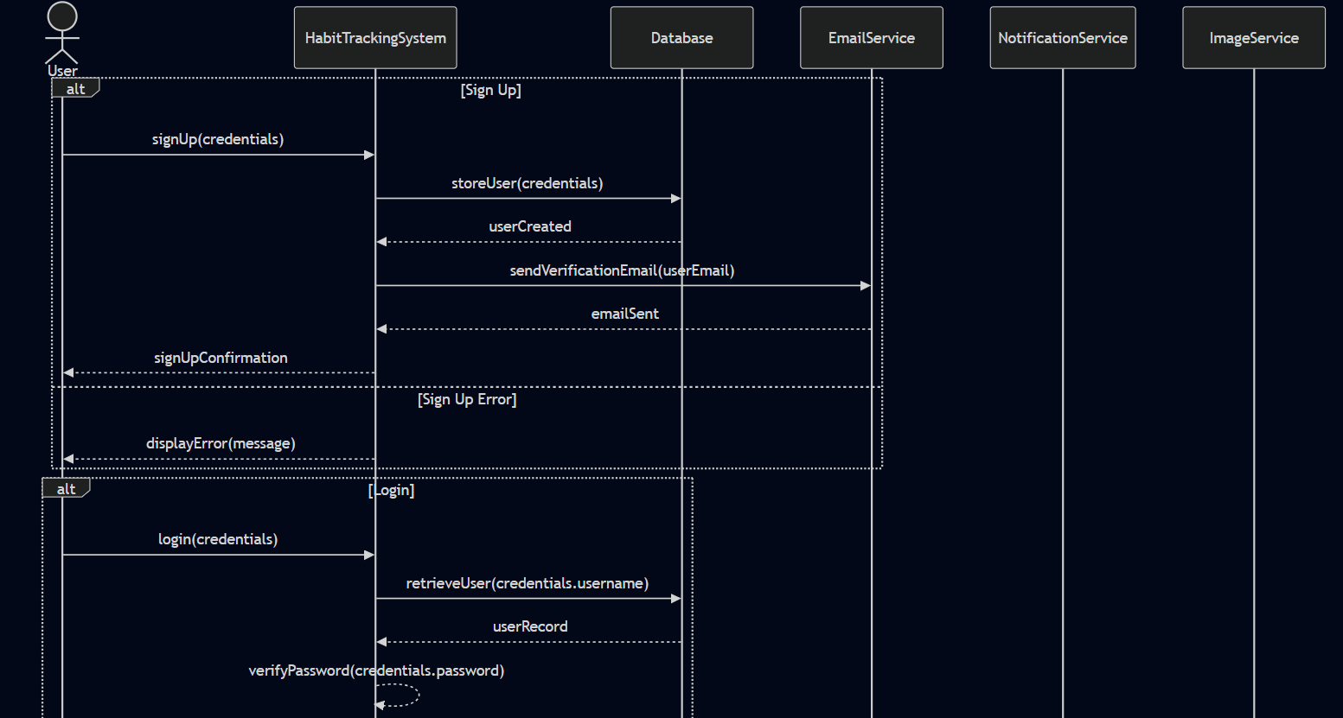

**Page 2:**

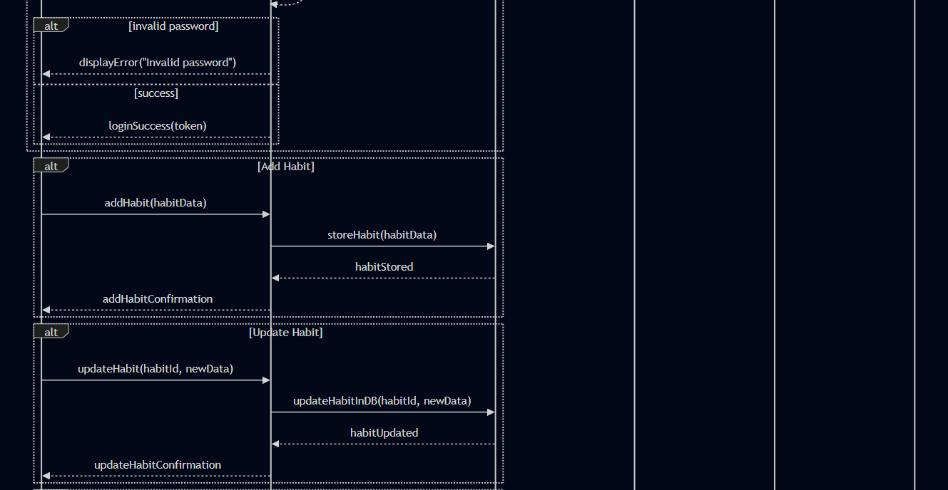

**Page 3:**

**Page 4:**

1. **Class Diagram:**

**Page1:**

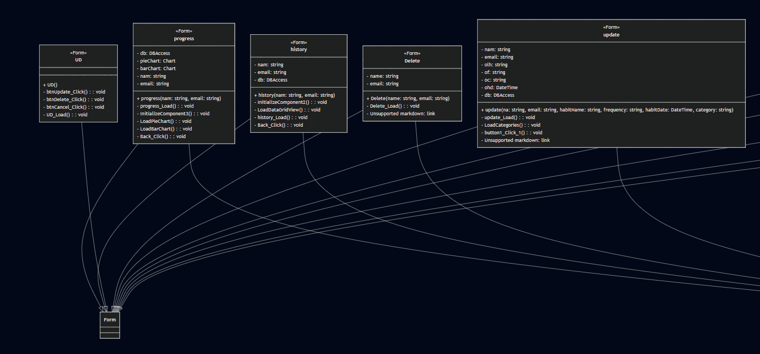

**Page 2:**

**Use Case Diagram:**

**Product Burn Down Chart**

**Testing**

**Boundary Value Analysis Testing (Sign -Up)**

|  |  |  |  |
| --- | --- | --- | --- |
| **Test Case Id** | **Input Values** | **Boundary Type** | **Expected Output** |
| **TC1** | Username="", Email="abc", Password="abc12" | Username: Black, Email: invalid missing @ and domain, Password: min-1 | Fail |
| **TC2** | Username="", Email="abc", Password="abc123" | Username: min-1, Email: invalid - missing @ and domain, Password: min | Fail |
| **TC3** | |  | | --- | |  |   Username="", Email="abc", Password="abc1234" | Username: min-1, Email: invalid - missing @ and domain, Password: min+1 | Fail |
| **TC4** | Username="a", Email="abc", Password="abc12" | Username: min, Email: invalid - missing @ and domain, Password: min-1 | Fail |
| **TC5** | Username="a", Email="abc@yahoo.com ", Password="abc1234" | Username: min, Email: invalid - not @gmail.com, Password: min+1 | Fail |
| **TC6** | Username="a", Email="abc@gmail.com", Password="abc123" | Username: min, Email: valid, Password: min | Pass |
| **TC7** | Username="ab", Email="abc@gmail.com", Password="abc1234" | Username: min+1, Email: valid, Password: min+1 | Pass |
| **TC8** | Username="user123", Email="abc@gmail.com", Password="habit@123" | Username: nominal, Email: valid, Password: nominal | Pass |
| **TC9** | Username="a", Email="abc@gmail.com", Password="habit@123" | Username: min, Email: valid, Password: nominal | Pass |
| **TC10** | Username="abc", Email="abc@gmail.com", Password="abcdef" | Username: nominal, Email: valid, Password: min | Pass |

**Boundary Value Analysis Testing(Login)**

|  |  |  |  |
| --- | --- | --- | --- |
| **Test Case Id** | **Input Values** | **Boundary Type** | **Expected Output** |
| **TC1** | Email="abc", Password="abc12" | Email: invalid missing @ and domain, Password: min-1 | Fail |
| **TC2** | Email="abc", Password="abc123" | Email: invalid - missing @ and domain, Password: min | Fail |
| **TC3** | |  | | --- | |  |  |  | | --- | | Email="abc", Password="abc1234" | | Email: invalid - missing @ and domain, Password: min+1 | Fail |
| **TC4** | Email="abc", Password="abc12" | Email: invalid - missing @ and domain, Password: min-1 | Fail |
| **TC5** | Email="abc@yahoo.com ", Password="abc1234" | Email: invalid - not @gmail.com, Password: min+1 | Fail |
| **TC6** | Email="abc@gmail.com", Password="abc123" | Email: valid, Password: min | Pass |
| **TC7** | Email="abc@gmail.com", Password="abc1234" | Email: valid, Password: min+1 | Pass |
| **TC8** | Email="abc@gmail.com", Password="habit@123" | Email: valid, Password: nominal | Pass |
| **TC9** | Email="abc@gmail.com", Password="habit@123" | Email: valid, Password: nominal | Pass |
| **TC10** | Email="abc@gmail.com", Password="abcdef" | Email: valid, Password: min | Pass |

**Architecture diagram**

**Lessons Learned by the Group**

**1.Communication:** Clear communication is essential for team collaboration.

**2.Time Management:** Setting deadlines helps keep the project on track.

**3.Adaptability:** Being flexible with changes leads to better outcomes.

**4.Feedback:** Regular feedback improves quality and team performance.

**5.Documentation:** Keeping detailed records aids future projects and knowledge sharing